Lab No: 05
Lab Name:
Banker’s Algorithm
Objectives:
- To understand the concept of deadlock avoidance in operating systems.
- To implement the Banker’s Algorithm using C programming language.
- To determine whether a system is in a safe or unsafe state.
- To generate the safe sequence of processes when the system is in a safe state.
Background Study:
Deadlock is a critical problem in operating systems where two or more processes are permanently blocked because each process is waiting for a resource held by another process. Once a deadlock occurs, no process can proceed, resulting in system inefficiency.
To prevent deadlock, operating systems use deadlock avoidance techniques, among which Banker’s Algorithm, proposed by Edsger Dijkstra, is one of the most important. This algorithm ensures that the system always remains in a safe state by carefully analyzing each resource request before granting it.
The Banker’s Algorithm checks whether allocating requested resources will keep the system in a state where all processes can complete their execution without causing deadlock.
The algorithm is based on the following four data structures:
- Allocation Matrix – Represents the number of resources currently allocated to each process.
- Max Matrix – Indicates the maximum number of resources each process may request.
- Need Matrix – Shows the remaining resource requirements of each process.
Need = Max − Allocation
- Available Array – Represents the number of currently available resources.
A system is considered safe if there exists at least one sequence of process execution such that all processes can complete successfully.
Characteristics of Banker’s Algorithm:
- Prevents the system from entering a deadlock state.
- Requires each process to declare its maximum resource requirement in advance.
- Performs safety checks before allocating any resource.
- Slightly slower due to repeated safety checks, but highly reliable.
Example (Given Problem):
Consider a system with 5 processes (P0–P4) and 3 resource types (A, B, C).
Allocation Matrix
Process | A | B | C
P0 | 0 | 1 | 0
P1 | 2 | 0 | 0
P2 | 3 | 0 | 2
P3 | 2 | 1 | 1
P4 | 0 | 0 | 2

Max Matrix
Process | A | B | C
P0 | 7 | 5 | 3
P1 | 3 | 2 | 2
P2 | 9 | 0 | 2
P3 | 2 | 2 | 2
P4 | 4 | 3 | 3
Available Resources
(3, 3, 2)
Algorithm:
- Start
- Input the number of processes and resource types
- Input Allocation matrix, Max matrix, and Available resources
- Calculate the Need matrix using:
- Need[i][j] = Max[i][j] − Allocation[i][j]
- Apply the Safety Algorithm:
  - Check if Need ≤ Available for any process
  - If yes, execute the process and release its resources
- Repeat until all processes are executed
- If a safe sequence exists → System is in safe state
- Else → System is in unsafe state
- Stop

CODE (C Program):
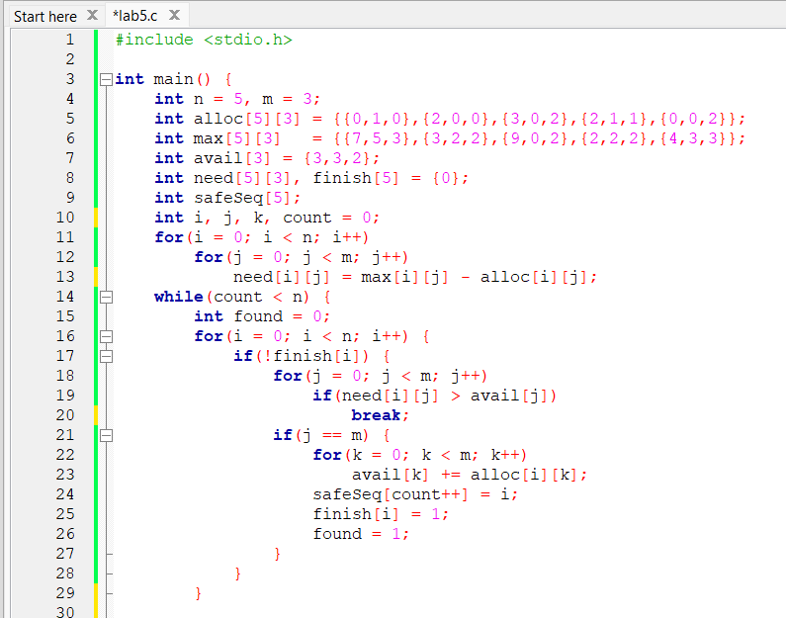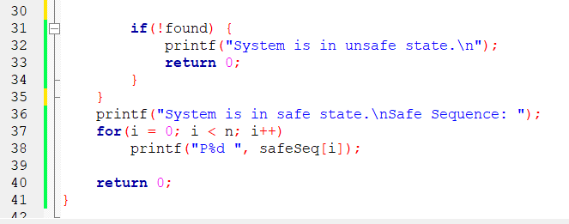

Discussion:
In this lab experiment, Banker’s Algorithm was successfully implemented using the C programming language to determine the safety of a system. The algorithm first calculated the Need matrix and then checked whether each process could be safely executed using the available resources.
Whenever a process completed execution, its allocated resources were released and added back to the available pool. This allowed other processes to execute safely. As a result, a valid safe sequence was generated, proving that the system was in a safe state.
Although Banker’s Algorithm is highly effective for deadlock avoidance, it requires prior knowledge of maximum resource demands, which may not always be feasible in real-world systems. Nevertheless, this lab clearly demonstrates the working principle of deadlock avoidance in operating systems.
Conclusion:
The experiment confirms that Banker’s Algorithm is an effective deadlock avoidance technique. By performing safety checks before resource allocation, the algorithm ensures that the system never enters an unsafe or deadlock state.

